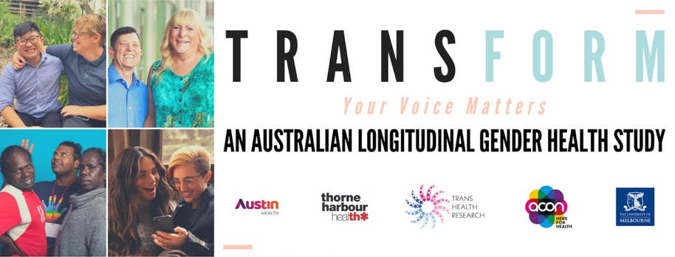

Guidelines for access to and use of data

Background
TRANSform is a community-led study of the health and well-being of trans including gender diverse and non-binary Australians. It was initiated by the Trans Health Research group at The University of Melbourne in collaboration with Austin Health, ACON Health NSW and Thorne Harbour Health. This study is committed to producing high quality science centered on the needs and well-being of Australia’s trans and gender diverse communities and for other collaborating researchers/organisations to use this resource. This document outlines guidelines of use for study data.

What constitutes ‘use’
Use of TRANSform data comprises any presentation or publication of data to internal or external audiences. Presentations may include information provided at meetings or conferences that include study results. Publications include reports, journal articles or any other communication (i.e., written, visual) that contains study results. Approval is not required for presentations or publications that describe the study but do not present results.

Approval for use of study data
Requests or proposals to use study data or to conduct a new substudy as part of TRANSform, including those from the investigative team, must complete and submit a concept/expression of interest sheet outlining key details (Appendix A). These will be submitted to Sav Zwickl (transform-research@unimelb.edu.au) and reviewed by the investigative team for comment and approval. Core investigators in TRANSform include Sav Zwickl, Alex Wong, Kalen Eshin, Teddy Cook, Daria Chetcuti, Ada Cheung and Lachlan Angus. Investigators will assess scientific validity, appropriateness of data use and relevance of research to the trans community. All projects must directly contribute to improving the health or well-being of the community or contribute to the education or training of a trans researcher. All projects will need approval by a human research ethics committee and there may be costs involved in this process. Investigators will provide written feedback and indicate their interest in being involved as a co-author.
No analyses may be undertaken that has not already been approved by a expression of interest form nor may an analysis exceed its approved scope. While the TRANSform human research ethics approval covers a diverse array of analyses, any that propose new kinds of processes (e.g., data linkage) will require additional, separate approval. Further, analyses that seek to specifically study subpopulations of trans and gender diverse people, notably Aboriginal or Torres Strait Islanders, sex workers or people living with HIV must undertake consultation with organizations representing the interests of those groups. Feedback on expression of interest forms will indicate where this is necessary.

Data storage and security
No data will be shared that could be used to potentially identify study participants. Regardless, anyone to whom access is provided must agree to treat the data as confidential and not share it with anyone beyond their authorship team. Further, data are to be stored in a password-protected format at all times and not to be stored on a detachable storage device, such as a USB key. If any data are stored on local systems (e.g., laptops, desktops), it is essential that the hard drives of these devices are encrypted.

Authorship and acknowledgements
Every TRANSform investigator has the right to be involved with any analysis arising from these data and can indicate their interest via this project’s expression of interest process. In all cases, at least one of the senior authorship spots (i.e., first, second, last or second last author) will be reserved for a member of this study’s investigative team. No output arising from these data without representation of one of the study’s trans and gender diverse investigators will be permitted. Publications utilizing TRANSform data are required to acknowledge any investigators not listed as co-authors by name.

Appendix A

TRANSform: An Australian Longitudinal Gender Health Study – Collaboration Expression of Interest Form
Submission date | 2020-06-20
Contact details
Submitted by
Organization
Email
Proposed study title:
Additional collaborators (beyond the TRANSform investigators – please highlight any trans researchers involved):
Background and overview (include references if required – may attach other document):
Objectives/aims/research questions:
Proposed analysis (describe in as much detail as possible):
Requested variables (please consult the data dictionary and list all required variables):
Potential limitations and additional considerations:
Potential significance of this research and how it will impact on improving the health or well-being of trans people:
Describe how the findings be used and reported including to ‘general’ audiences:
Review outcomes (for internal use only):
For any questions or to submit completed expression of interest forms, please contact transform-research@unimelb.edu.au

